**Experiment No. 9**

1. **Aim/Overview of the practical:**

Create and maintain file storage using file storage.

1. **Code for practical:**

* Open Azure portal and go to ***resources>storage>storage account>create***.

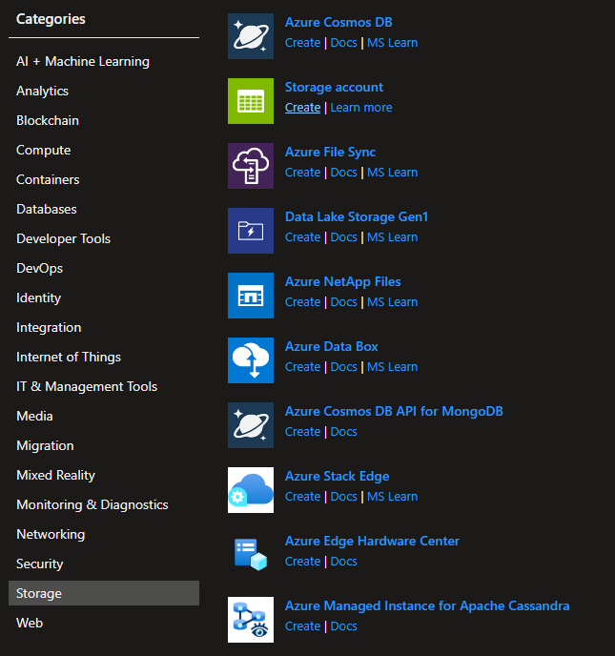

* Enter name of resource and select plan to premium and select file storage.
* Click on create button.
* Your resource will be deployed in few moments.

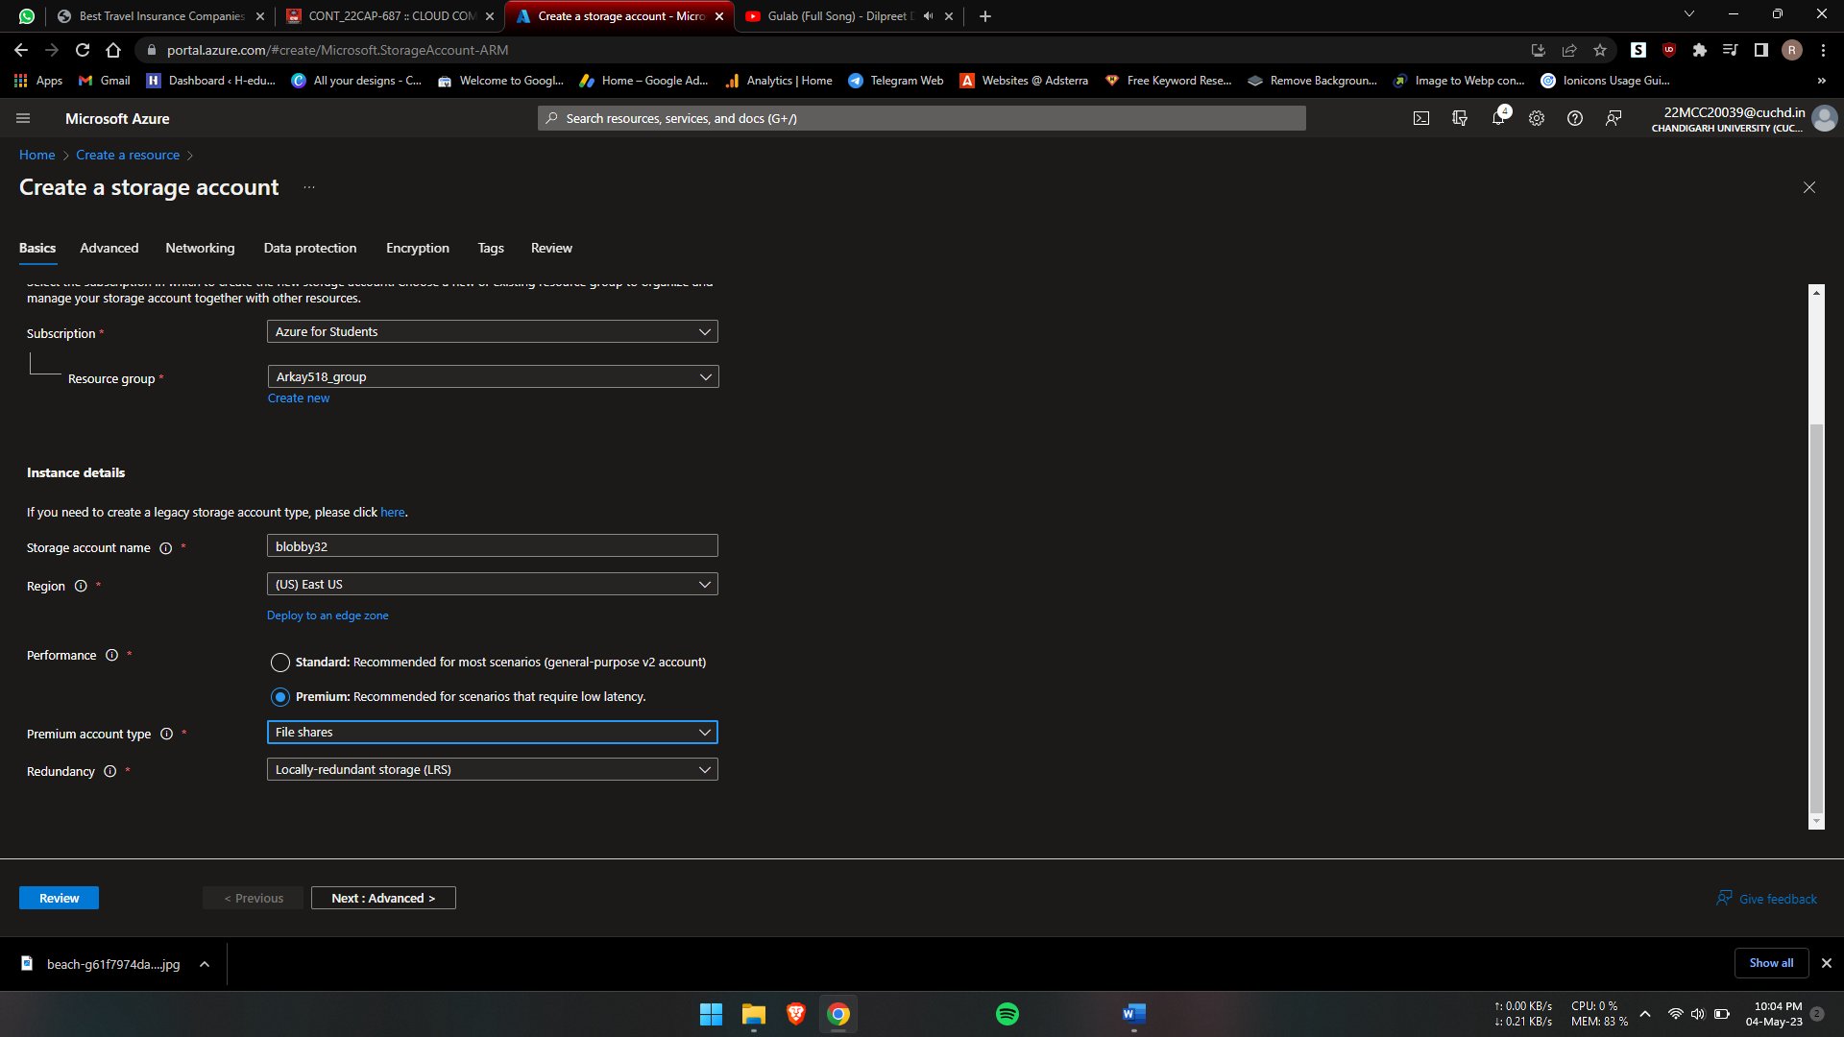

* Click on upload and upload and file or directory.

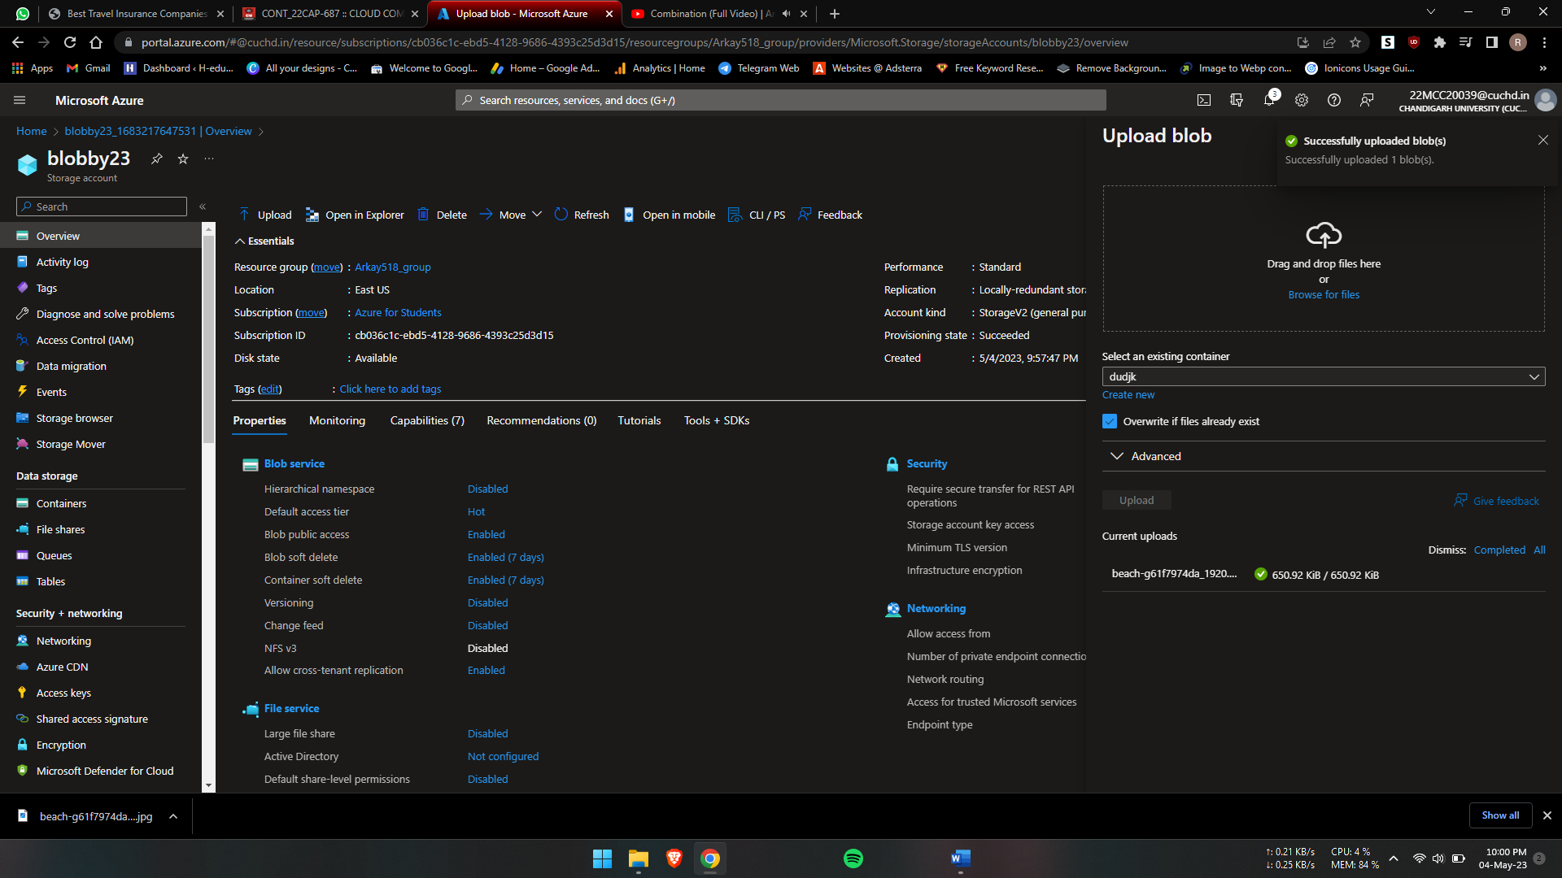

* Select and copy the Script on notepad.

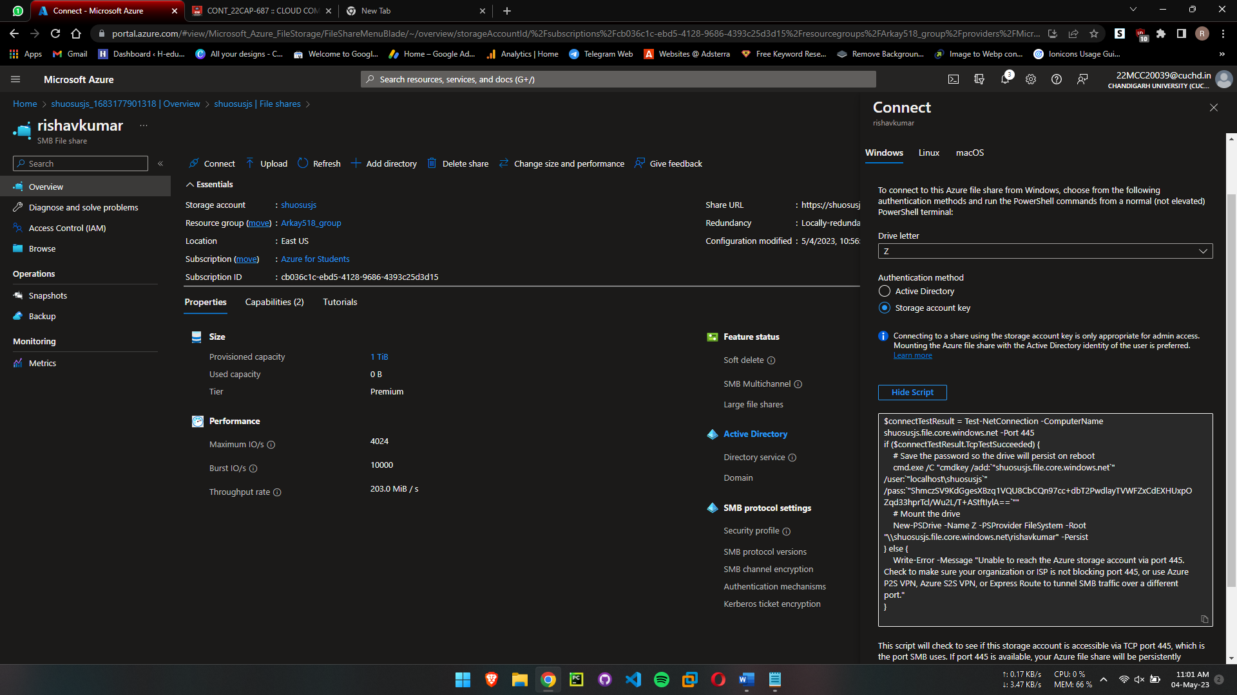

* Now open This PC and click right click > map network drive.
* Enter the path from notepad code.

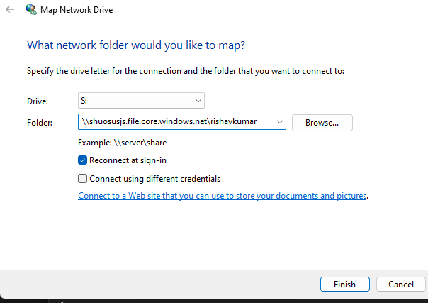

* Now enter username and password from file and click on connect.
* Now you’re connected to file storage.

**************************************** **THE END** ***********************************************